BUG:

A software bug is an error, flaw or fault in the design, development, or operation of computer software that causes it to produce an incorrect or unexpected result, or to behave in unintended ways. The process
of finding and correcting bugs is termed "debugging".

ERROR:

An Error is a mistake made in the code; that's why we cannot execute or compile code. The Fault is a state that causes the software to fail to accomplish its essential function. If the software has lots of defects,it leads
to failure or causes failure.

DEFECT:

A bug is a fault in the software/code that causes it to malfunction. In contrast, a defect is a flaw in a product that reduces its value or usability.A software bug arises when the expected result don't match with the
actual results. It can also be error, flaw, failure, or fault in a computer program. Most bugs arise from mistakes and errors made by developers, architects.

FAILURES:

A failure is the inability of a software system or component to perform its required functions within specified performance requirements. When a defect reaches the end customer it is called a Failure. During
development, Failures are usually observed by testers.

BUG/DEFECT LIFE CYCLE
Defect life cycle, also known as Bug Life cycle is the journey of a defect cycle, which a defect goes through during its lifetime. It varies from organization to organization and also from project to project as it is governed by the software testing process and also depends upon the tools used.
A bug life cycle in software testing is a set of statuses designed to coordinate defect management. A bug status helps keep all the members of the development team posted on the progress.

WHEN IT IS USED?

The cycle starts when a QA engineer reports a new issue found in the tested software and finishes when this issue is sold.

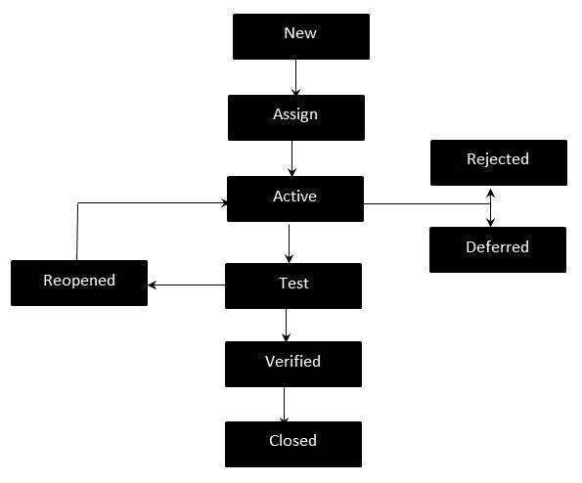
- New - Potential defect that is raised and yet to be validated.

- Assigned - Assigned against a development team to address it but not yet resolved.

- Active - The Defect is being addressed by the developer and investigation is under progress. At this stage there are two possible outcomes; viz - Deferred or Rejected.

- Test - The Defect is fixed and ready for testing.

- Verified - The Defect that is retested and the test has been verified by QA.

- Closed - The final state of the defect that can be closed after the QA retesting or can be closed if the defect is duplicate or considered as NOT a defect.

- Reopened - When the defect is NOT fixed, QA reopens/reactivates the defect.

- Deferred - When a defect cannot be addressed in that particular cycle it is deferred to future release.

- Rejected - A defect can be rejected for any of the 3 reasons; viz - duplicate defect, NOT a Defect, Non Reproducible.

